**Section 4**

**TRUNC**

select hiredate,

trunc(hiredate,'month')

from singer;

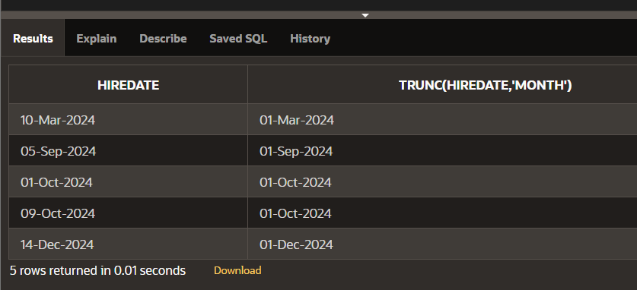

**ROUND TO HIREDATE**

select hiredate,

round(hiredate,'month')

from singer;

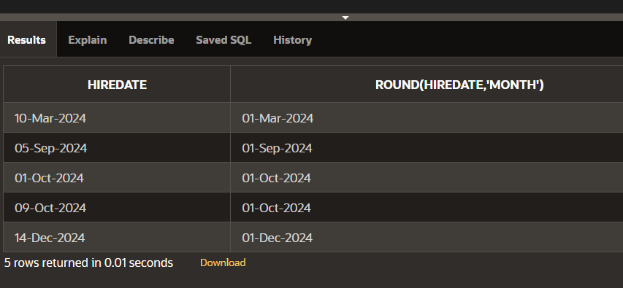

**LAST DAY**

select last_day(sysdate)

from dual;

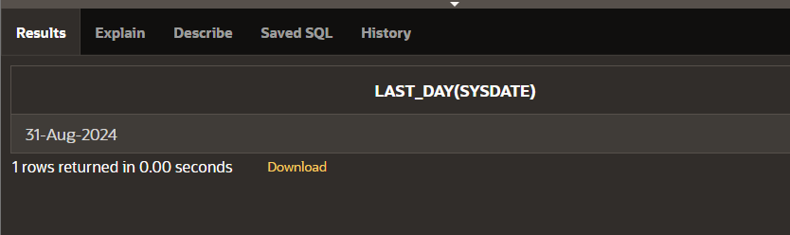

**NEXT DAY**

select next_day(sysdate,'monday')

from dual;

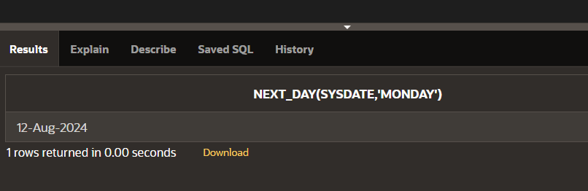

**ADD MONTHS**

select add_months(sysdate,5)

from dual;

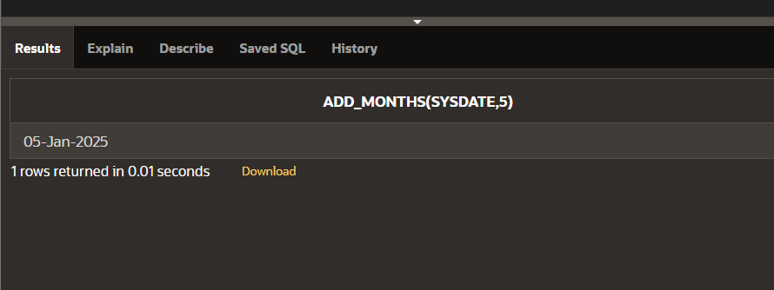

**MONTHS BETWEEN**

select id,name

from singer

where months_between

(sysdate,hiredate)<100;

